Project Design Phase-II

Data Flow Diagram & User Stories

|  |  |
| --- | --- |
| Date | 23June2025 |
| TeamID | LTVIP2025TMID60646 |
| ProjectName | Visualizing the house market trends: an analysisofthesalepricesfeaturesusingwith the tableau |
| MaximumMarks | 4Marks |

# DataFlowDiagrams:

A Data Flow Diagram (DFD) is a traditional visual representation of the information flows within a system. A neat and clear DFD can depict the right amount of the system requirement graphically.Itshowshowdataentersandleavesthesystem,whatchangestheinformation,and where data is stored.

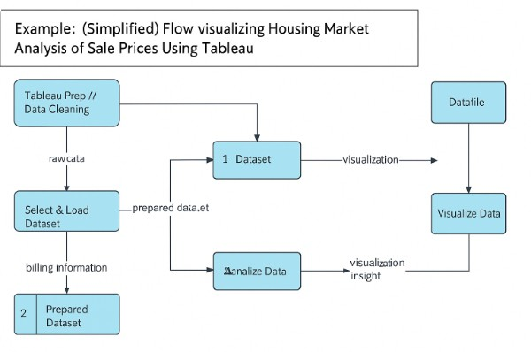

# UserStories

Usethebelowtemplatetolistalltheuserstoriesfortheproduct.

|  |  |  |  |  |  |  |
| --- | --- | --- | --- | --- | --- | --- |
| **User Type** | **Functional Requiremen t (Epic)** | **User Story Number** | **UserStory/Task** | **Acceptance criteria** | **Priority** | **Release** |
| Customer (Mobile user) | Registration | USN-1 | As a user, I can register for the applicationbyenteringmyemail, | Icanaccessmy account / dashboard | High | Sprint-1 |

|  |  |  |  |  |  |  |
| --- | --- | --- | --- | --- | --- | --- |
| **User Type** | **Functional Requiremen**  **t(Epic)** | **User Story**  **Number** | **UserStory/Task** | **Acceptance criteria** | **Priority** | **Release** |
|  |  |  | password,andconfirmingmy password. |  |  |  |
| Data Analyst | Trend Analysis | USN-1 | Asauser,Iwanttoviewmonthly sales price trends so I can understand market growth | A line graph displaysaverage monthly sales prices correctly. | High | Sprint-1 |
| Data Analyst | Regional Comparis on | USN-2 | As a user, I want to compare averagehomepricesbycityto identify high-demand areas. | A bar chart shows averagepricesper city, sortable by price. | Low | Sprint-2 |
| RealEstate Agent | Feature-bas ed Pricing | USN-3 | Asauser,Iwanttoexplorehow square footage and bedrooms affect pricing | A scatter plot shows price vs. square footage, withcolor-coded bedrooms. | Medium | Sprint-1 |
| Home Buyer (Web) | Interactive Filtering | USN-4 | Asauser,Iwanttofilterthe dashboardbyyear,property type, and city so I can view relevant information. | Filtersapplytoall charts on the dashboard dynamically | High | Sprint-1 |
| Business Manager | Summary KPIs | USN-5 | As a user, I want to see key metrics like average price, medianprice,andtotallistings to track overall performance. | KPIsupdatebased on current filter selection | High | Sprint-1 |
|  |  |  |  |  |  |  |
|  |  |  |  |  |  |  |
|  |  |  |  |  |  |  |
|  |  |  |  |  |  |  |

|  |  |  |  |  |  |  |
| --- | --- | --- | --- | --- | --- | --- |
| **User Type** | **Functional Requiremen**  **t(Epic)** | **User Story**  **Number** | **UserStory/Task** | **Acceptance criteria** | **Priority** | **Release** |
|  |  |  |  |  |  |  |
|  |  |  |  |  |  |  |